Sql Project

Hello 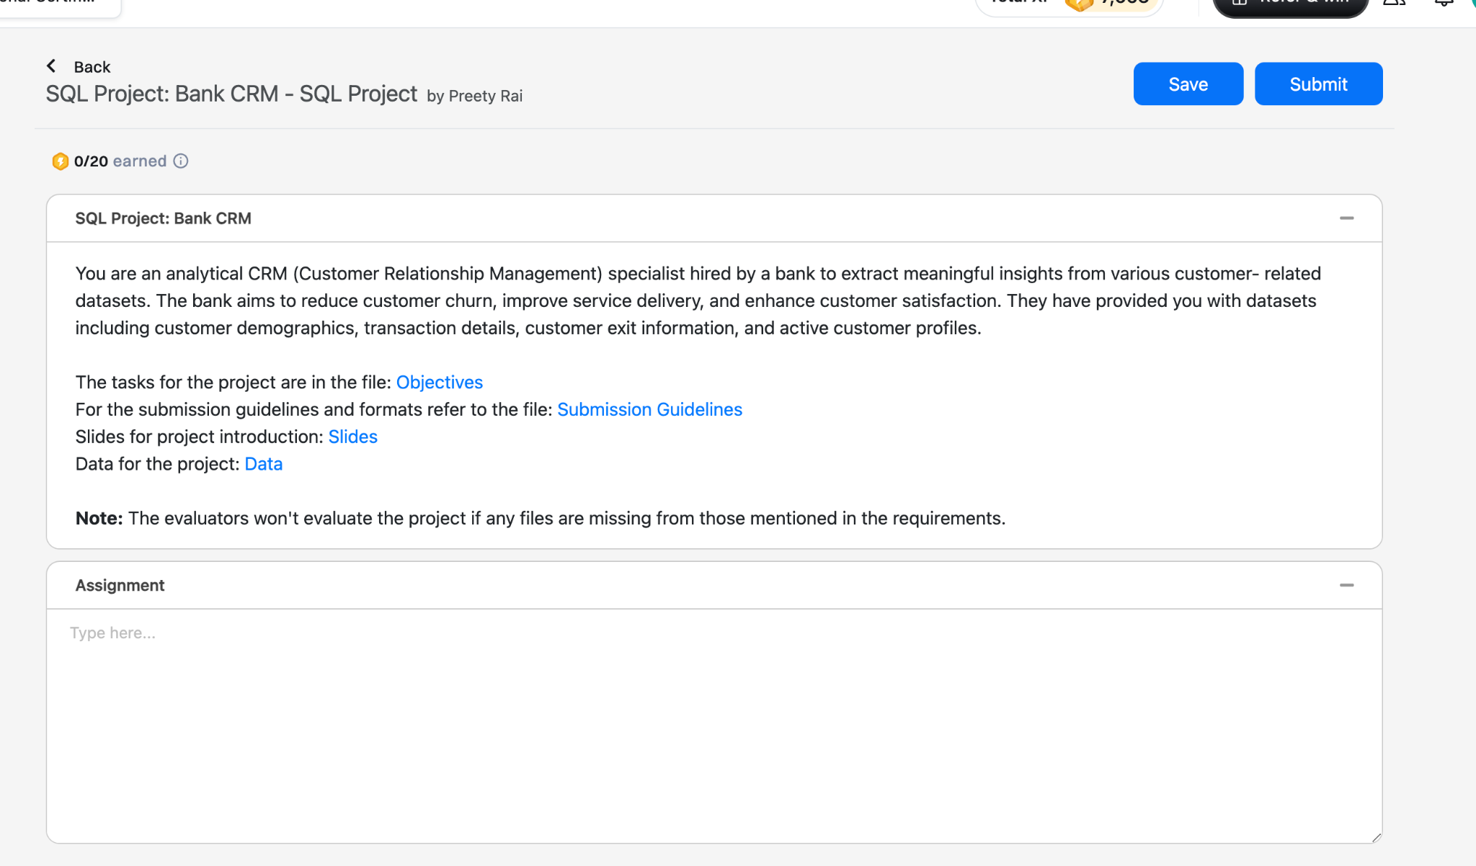

Fsfsfsfsffsf Objecjtive :- <https://docs.google.com/document/d/1I4pxGbB3rdrZowmbsxLz2EjnC452x7H0VGfMeeCk67E/edit?usp=sharing>

Submission Guidelines:- <https://docs.google.com/document/d/1VYlJ0hkWzInaDJR7sH5WIQSNixwwaRGOQLUFudhTafw/edit?usp=sharing>

Submission Guidelines:- <https://docs.google.com/document/d/1AVkKo3lSdoZ_huGiezaz5TQf2OQOWqTVQOLw2gP8G3Y/edit?usp=sharing>

Datasset:-